In order to initiate a CN Re-notification, Program Officers must log in to PAMS and access the fully obligated project that is being re-notified. **Initiating a CN Re-notification is different from the normal CN process and can only take place after a project has been fully obligated. If your project has not been fully obligated and needs to be renotified, please speak to the PAMS team and your Budget Analyst before initiating a renotification.**

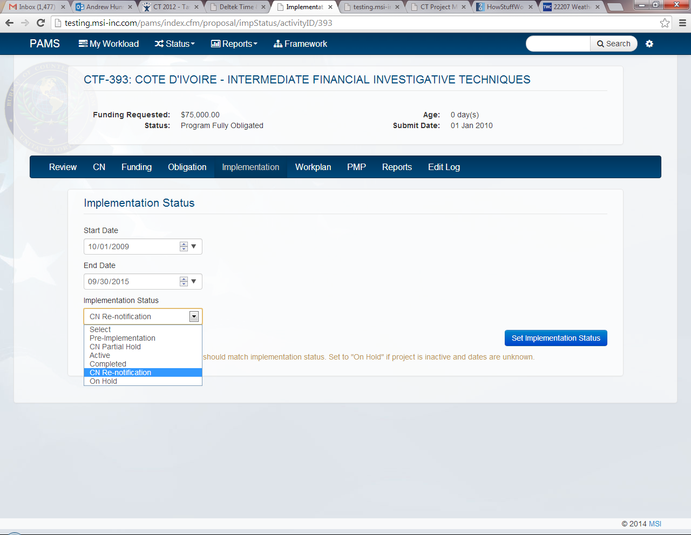Program Officers will log in to PAMS, access the project in question, and select the **“Implementation”** tab.

Program Officers will select “**CN Re-notification”** and then select **“Set Implementation Status “**to initiate the Re-notification process.

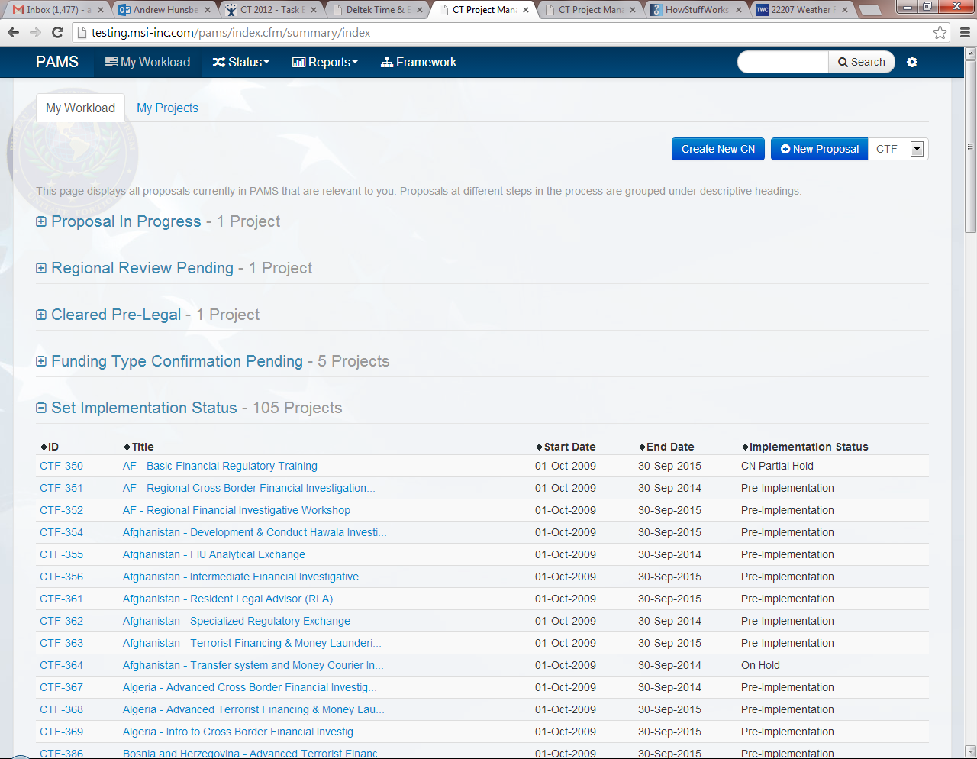Once the CN Re-notification status has been set, Program Officers will access their Workload and select **“Create New CN”**.

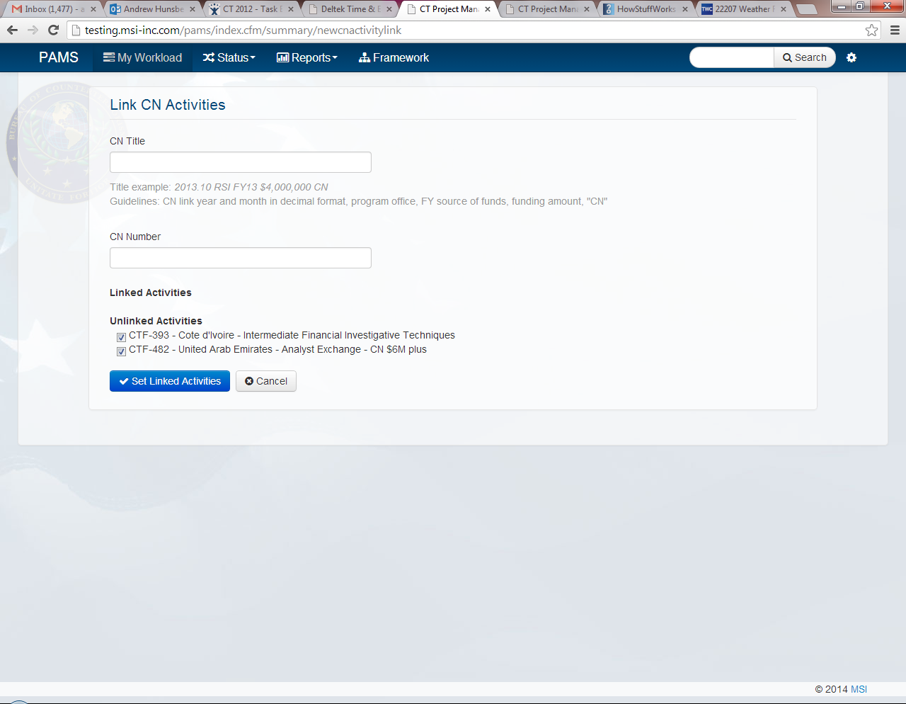Program Officers will enter a **CN title,** a **CN number**, and **select the Re-notified project(s) to be created** in the CN Re-notification.

Once the CN Re-notification information has been entered and the relevant projects have been selected, Program Officers will select “**Set Linked Activities”** to create a CN Re-notification.

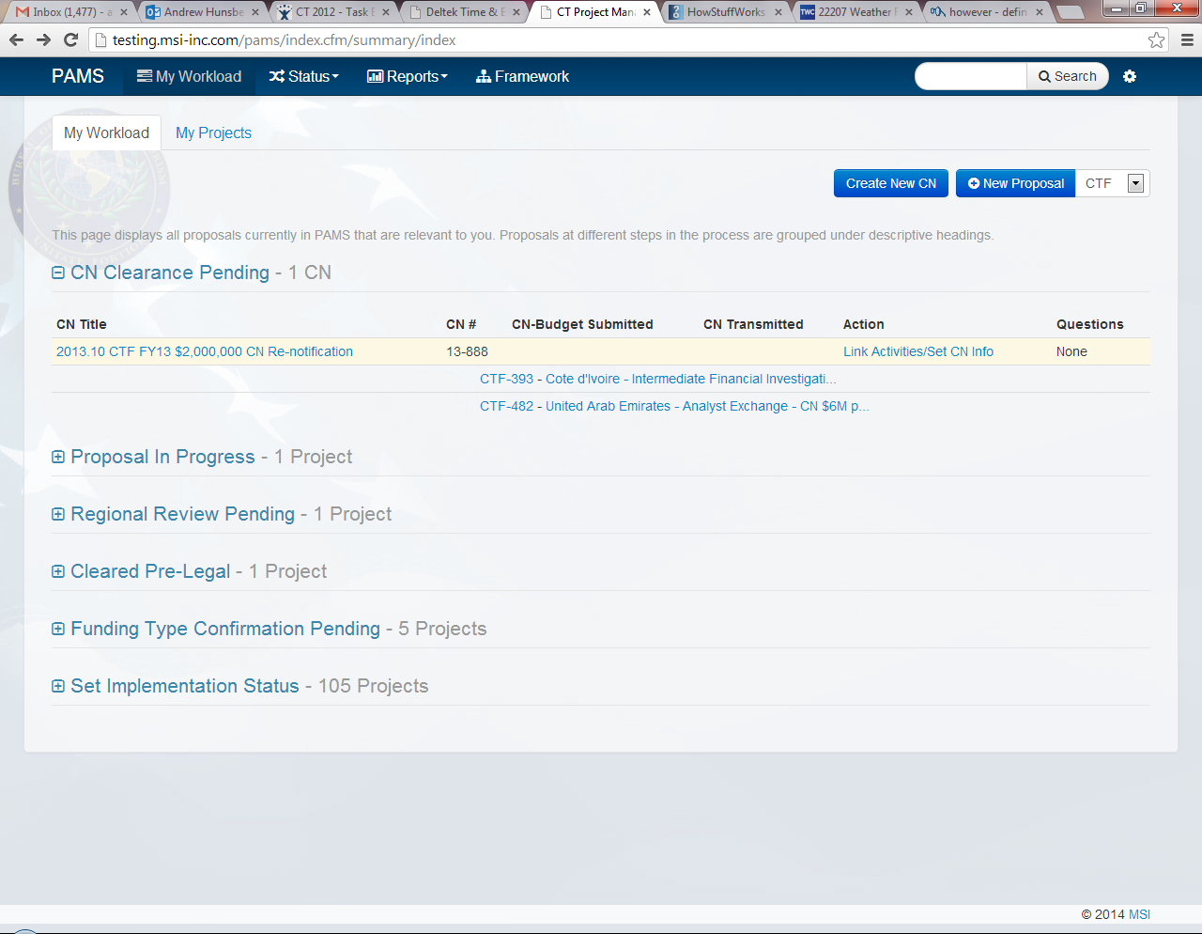Program Officers will now be able to access their newly created CN Re-notification on their Workload under **“CN Clearance Pending”**.

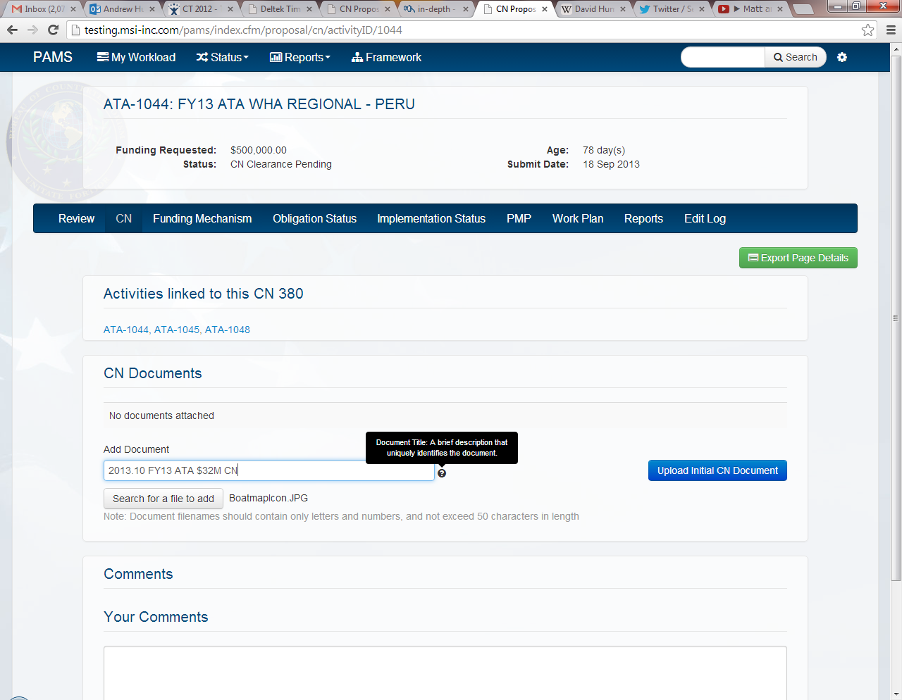In order to submit the CN Re-notification to Budget, Program Officers will open their newly created CN Re-notification, open the CN tab, upload a CN Re-notification document, and enter a document title. **The CN Re-notification has not been officially submitted until this step occurs.**

Once a document has been uploaded and titled, Program Officers will select **“Upload Initial CN Document”** to complete the submission process. *Budget will automatically be notified via email that the project in question is ready for CN Re-notification clearance*

**\*\*\*NOTE**: CN document file names should contain simple characters and **no commas**.CN document file names with commas will not open in Google Chrome.

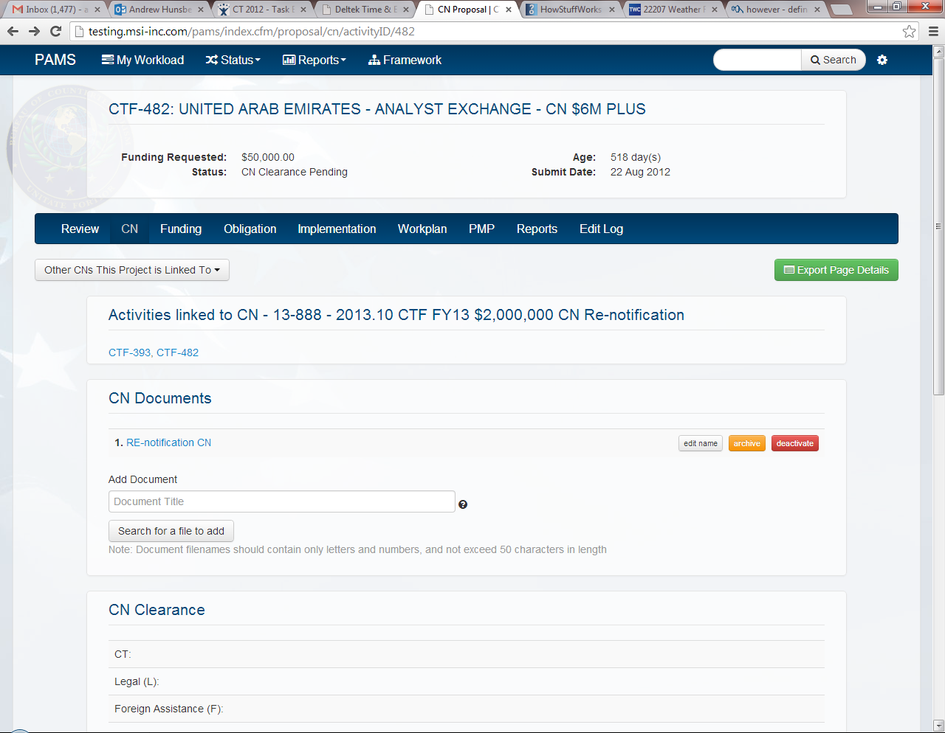Program users will be able to check the status of the current CN Re-notification via the CN page. Program users will also be able to view the CN clearance history of the project’s original CN by selecting   
**“Other CN’s This Project is Linked To”.**